CATEGORY: | CYLINDRICAL GRINDING MACHINE
Manufacturer: | BERCO
Model: | RUY 300/3000
Centre height | 300 mm / 11 13/16”
Centre distance | 3000 mm / 118 7/64”
Mandrel rotating speeds (n. 12) | from 14 to 220
Max grinding diameter | 600 mm / 23 5/8”
Wheel centre head stroke (fast) | 50 mm / 1 31/32”
Wheel centre head stroke (fast) | 150 mm / 5 29/32”
Grinding wheel max diameter | 650 mm / 25 19/32”
Max table tilt | 3° 30′
Total power | 27,7 HP
Dimensions | 7100 x 2300 mm / 23.35 Ft x 7.65 Ft
Approximate weight | 11800 kg / 26,014 lbs
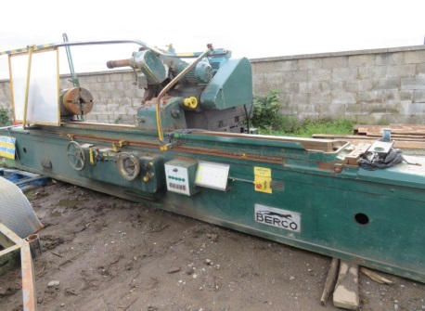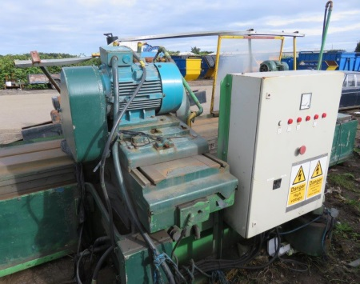
BERCO RUY 300/3000 GRINDING MACHINE

