Technical Specifications Bowen S3.5 Power Swivel Skid Mounted Full Rebuild 4th Quarter 2022

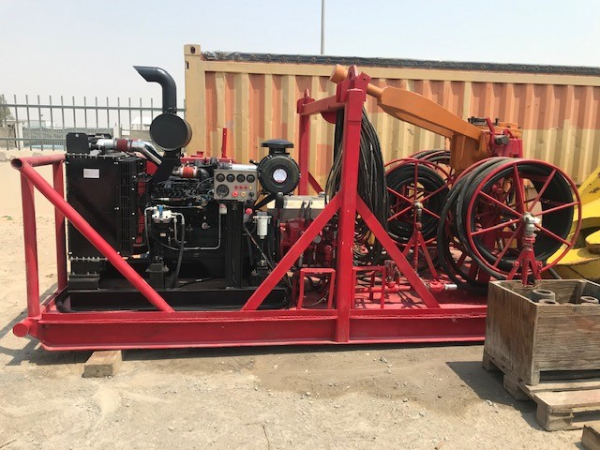

ID Number: | 0506-0-003-C | Unit serial number: | #998
Operating Hours: | Zero | Present Location: | Hamriyah, UAE
Assembly Part Number: | 84550 | Inspection and testing: | Re-Build Late 2022

Manufacturer: | Bowen | Model: | S 3.5 (PS 120)
Rated capacity: | 120T | Engine Horsepower Continuous: | New Cummins 6BTAA5.9-C205 210 Bhp@ 2200 RPM
Hydraulic Pumps | Sauer Danfoss SPV25 | Hydraulic Motor | Sauer Danfoss SMF22
Maximum Circulating Pressure: | 5,000 PSI | Maximum Speed RPM: | 150

Height: | 70” (1.78m) | Width: | 84” (2.14m)
Length: | 144” (3.66m) | Weight: | 11,500 Lbs. (5216 kg)

Radius of Torque Rein Telescoped: | 44 1/8” | Radius of Torque Rein Extended: Telescope | 64 1/8”
Bore thru stem : | 2-1/4” | Elevator Bail Pipe Size: | 3 ½” & 4 ½”
Bail Hook Clearance: | 23-1/4” | Goose Neck connection: | 3” -8 Line Pipe Thread
Maximum Torque: | 8,100 Ft Lbs. | Saver Sub Connection: | 3.5” IF
Saver Sub make up torque: | 7,500/10,000 Ft Lbs. | HP Hose Connection Forward : | 1-1/4” x 120’
Max. RPM: | 150 | HP Hose Connection Reverse: | 1-1/4” x 120’
HP Hydraulic Hose Connection | Quick Release | Case Drain Hose Size: | 1” x 120’

